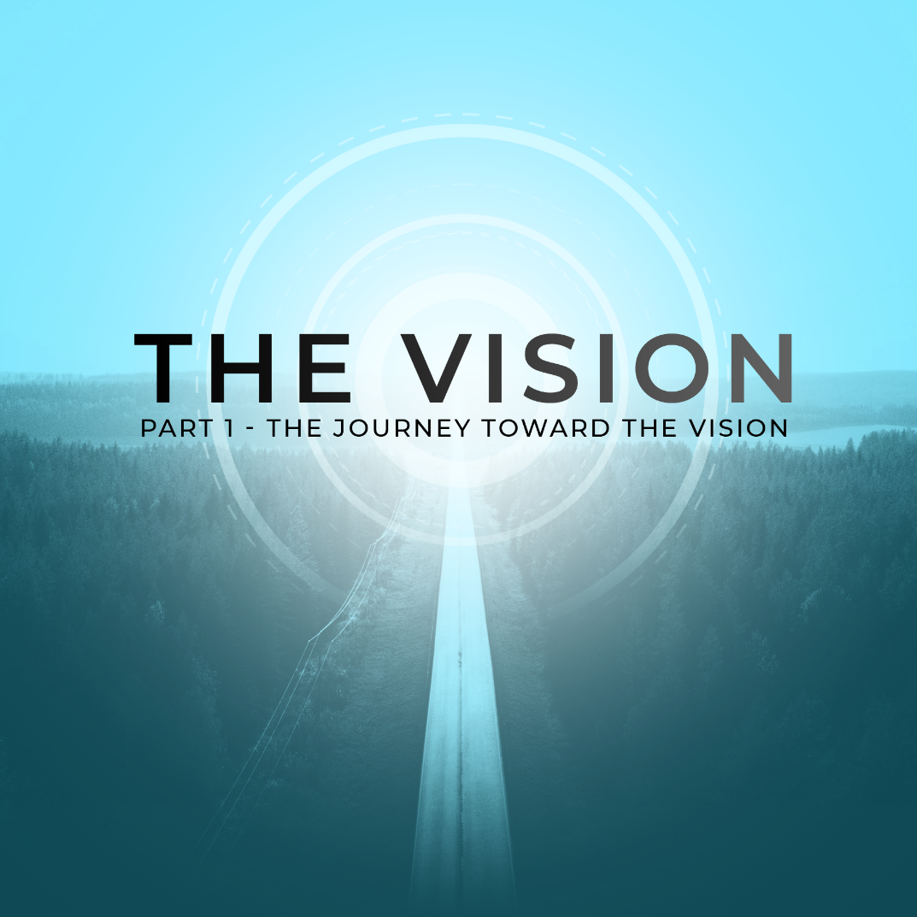

Let's take an inventory of our lives and consider where we want to be in the future as we begin a new chapter for 2023. We will be talking about THE JOURNEY TOWARD THE VISION. We will look into the THREE SEASONS you may find yourself in as you journey through life with Christ: The Waiting Season, The Writing Season, and The Working Season.

Habakkuk 2:2-3 - “2 Then the Lord replied: “Write down the revelation and make it plain on tablets so that a herald may run with it. 3 For the revelation awaits an appointed time; it speaks of the end and will not prove false. Though it linger, wait for it; it will certainly come and will not delay.” (NIV)

THE WAITING SEASON

The fast-paced society of today teaches us that we must hustle. We should be movers and shakers, making things happen! In our minds, waiting suggests that we are falling behind. Waiting may make us feel like life is passing us by and that everyone else is achieving, advancing, and accelerating faster than we are. Waiting makes us uncomfortable, we become fidgety and frustrated.

In our spiritual lives, waiting is the process of tuning in to God through prayer and asking for His guidance. We may have mistakenly thought that to “wait” means we would sit passively, doing nothing more than praying. Allow me to present an alternative viewpoint.

God has placed a special gift inside of you. 1 Peter 4:10 says, “Each of you should use whatever gift you have received to serve others, as faithful stewards of God’s grace in its various forms” (NIV). This encourages us to use our gifts and talents to serve the body of Christ. This is an indicator that we should never be idle, doing nothing. While you are waiting on God, why not actually serve him? Waiting on God means that you are literally being of service to Him. What does HE need? What does HE want?
Being of service to God means that you are lending your hands to His work. This work may not necessarily be in a church setting. You will not have to look very far in your community to see areas where you can serve. There is an entire world around you that can be blessed by your gifts.

If you find yourself in a Season of Waiting, here are three things you need to have while you wait on the Lord:

Patience
As we go through our season of waiting, we must be patient. Our impatience with our process shows a lack of trust in God. It is through the patience of going through our process that God develops His character in us. It is during these times that we can focus on ‘the little things’ that can prevent us from our greatness in Christ. Who are you when no one is watching?

Perseverance
We can remain dedicated by renewing our minds in the Word of God. We can replace the negative whispers of the enemy with the truth of God’s Word. Our internal dialogues should agree with God’s standard for what we should think about. We should abide by the Lord and never give up on the waiting process.

Perspective
Having the proper perspective will allow you to see people and situations as God sees them. This will require a commitment to prayer and asking God to give you insight and wisdom that you cannot obtain without Him. His ways are not our ways and His thoughts are not our thoughts. He can reveal things in prayer that we do not know.

THE WRITING SEASON

Habakkuk 2:2 instructs us to write the vision. Writing the vision leads us to obey what God has asked us to do. The simple act of writing down what the Word of God says shifts us from being a passive, laid-back hearer to an active, engaged doer. Remember: Acting on God’s instruction puts us in a position to receive His best.

Writing also brings a sense of clarity to our thoughts. Clarity is important because it provides focus. Instead of wandering aimlessly, writing the vision allows us to zero in on our heart’s desire. Putting pen to paper brings our desire center stage.

God is pleased when we write in faith. Hebrews 11:1 says “Now faith is confidence in what we hope for and assurance about what we do not see (NIV).” Your writing, by faith, is the material that your future victory is made of. When things are difficult, revisiting the vision you wrote down will help you stay the course. Writing down the vision spoken to you by God will be a visual reminder of your future win.

If you really want to hear from God, you will have to be intentional about shutting out all outside distractions. Too many times we are listening to everything and everybody else – but God. In the middle of all this noise, God may have already been speaking. Often we miss it because we don’t allow ourselves any time for quiet time with God.

You may not hear a thunderous voice of God coming down from the clouds outside your house, but you may hear Him speaking in quiet impressions on your heart. As you sit in His presence, God-inspired thoughts will fill your mind. He will give you brilliant God-ideas that you could not come up with on your own. This is what you need to write. It may take some time to develop this new discipline of being still before God and writing the vision. It does not happen overnight, but God blesses us in our consistency. Small consistent steps toward Him will steadily move you closer.

THE WORKING SEASON

The Working Season is the time when you are actively walking toward what God has revealed to you during your Writing Season in prayer. It is in this season that you are functioning in obedience and following His direction. In the Working Season, you are being used by God to promote His Kingdom and bring Him glory. As you do what God has called you to do, you find fulfillment in His purpose for you.

If you feel that the vision you’ve received from God is beyond your reach, the first thing you must do is adjust your focus. Check your eyes and renew your vision. It’s just like putting on eyeglasses with the correct eye grade. In order to walk in the fulfillment of God’s purpose for your life, you must see yourself as God sees you. Look at yourself through God’s lens. Resist the urge to see yourself as less than others. Whatever we think in our hearts, that’s exactly what we are. How you see yourself determines how you show up in the world.

Agree with God and look at yourself through His eyes. Scripture says in Ephesians 2:10 that we are God’s masterpiece. Genesis 1:27 reminds us that we are created in the image of God. According to Psalm 8:5, we are crowned with glory and honor. The assurance of knowing that you are created in God’s image and are His masterpiece should cause you to fully stand up and own the greatness He has placed within you. You can do and be everything God has called you to be when your focus is right.

As believers, we can do nothing without His power. The Holy Spirit empowers us to operate and be effective in what God has called us to do. It is not in our own strength. It is God who gets the work done. Zechariah 4:6 reminds us that great things are accomplished by the power of His Spirit, not our strength. The vision that God placed in your heart may, in fact, be far beyond what you can do in your own strength. This is precisely why you need HIM to accomplish it!

REFLECT:
Take a moment to listen to the ongoing conversation you are having with yourself. What are you saying? Are you speaking words of life to yourself or are you speaking death? Are you encouraging yourself or are you speaking words of self-doubt and defeat?

Make the mental shift to replace the negative internal thoughts with the Word of God. In order to fulfill God’s purpose, you must make a conscious choice to speak words that agree with God’s Word and what He has said about you. You must remind yourself of His thoughts about you multiple times throughout the day. Change your internal dialogue and come to an agreement with God.

Often we delay and miss opportunities to be used by God because we worry about making the wrong move. Fear paralyzes us, causing us to do nothing. It is critical that we face our fear by focusing on God’s vision. We must push past the fear of making a mistake. As we follow God in faith, He fills in the gaps. He’s gracious to forgive the mistakes we may make as we pursue what we believe He called us to do. God sees our hearts to please Him, and if we stumble, He will allow mistakes to work for our good.

Once you begin to make steps, in faith, God will bring people into your life with divine alignment to your assignment. He will strategically put people in your path to help you fulfill what He has called you to do. Please don’t dismiss meeting some people as a coincidence – see them as divine connections.

As you begin to walk in what God has called you to do, please keep in mind a few things: 1. God’s vision for your life may not manifest in the way you expect it. Be open to how the vision will unfold. His plans may be birthed in a place you have not considered before. 2. Take time to prepare yourself for the vision by actively working on your spiritual growth and personal development. Remember, numerical success does not equal spiritual success. Your effectiveness will not be based on man’s measure of success but on God’s. When we obey His voice, we always win!

LIFE GROUP DISCUSSION:

1) What is your vision or goal for 2023? How do you plan to accomplish it?

2) Do you feel like you are in a waiting season right now? What are you waiting for?

3) What is the benefit of waiting on the Lord? How are you changed when you wait on the Lord?

