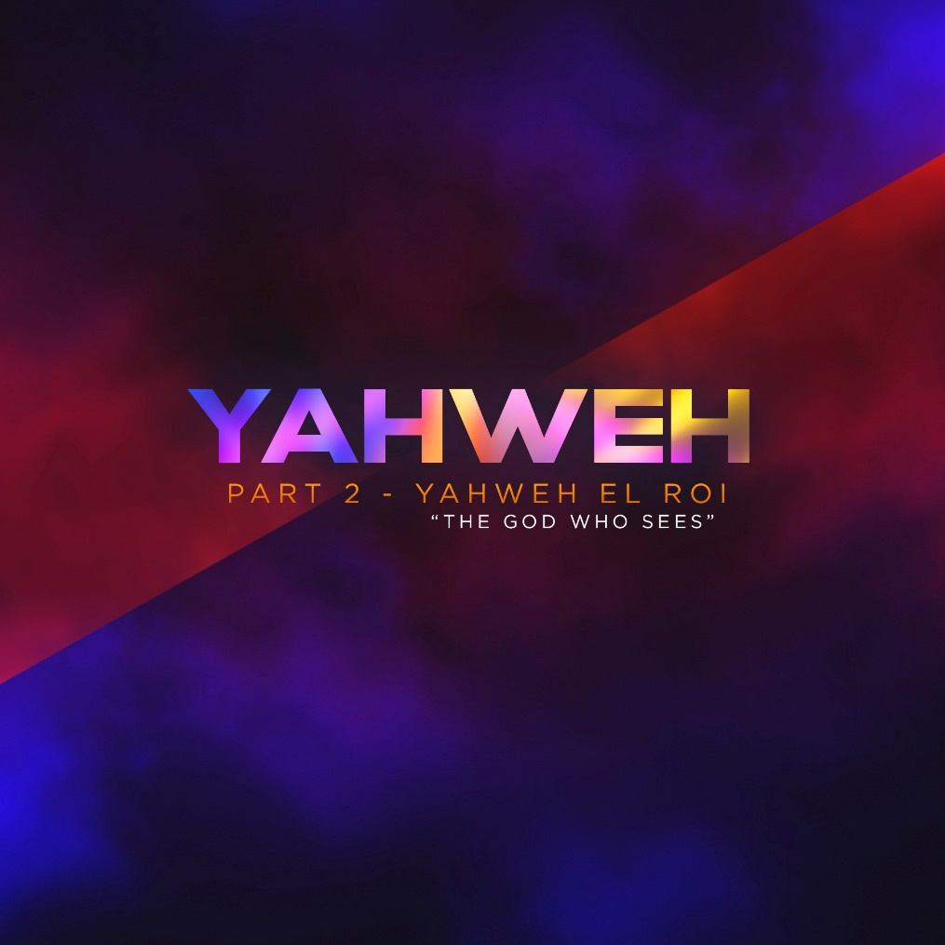

This a story of a couple who at their late age, has not been blessed with a child. This couple is a God-fearing couple. In fact, the Lord has promised to give them a child. But the waiting took many years and consumed and frustrated the wife, so she took matters into her hands. To find solution to their longing of having a child, she gave her house helper or yaya to her husband to make love to her so that their family line would be preserved.

Although hesitant and fearful, the helper obeyed her boss and did what she was asked to do. Eventually, she got pregnant but she was treated harshly by her lady boss. So, she ran away. She became bitter. She didn’t ask for this kind of life, but her life became miserable. The abuse was enough to cause her to run away - alone and pregnant. Away from people. Without any resources. A child on the way. Talk about coming to a place of nothing, and this woman had it all.

This is the story of Abraham and Sarah - the couple, and Hagar, the slave.

WORD

Genesis 16:1-13 - “1 Now Sarai, Abram’s wife, had borne him no children. But she had an Egyptian slave named Hagar; 2 so she said to Abram, “The Lord has kept me from having children. Go, sleep with my slave; perhaps I can build a family through her.” Abram agreed to what Sarai said. So after Abram had been living in Canaan ten years, Sarai his wife took her Egyptian slave Hagar and gave her to her husband to be his wife. 4 He slept with Hagar, and she conceived. When she knew she was pregnant, she began to despise her mistress. 5 Then Sarai said to Abram, “You are responsible for the wrong I am suffering. I put my slave in your arms, and now that she knows she is pregnant, she despises me. May the Lord judge between you and me.” 6 “Your slave is in your hands,” Abram said. “Do with her whatever you think best.” Then Sarai mistreated Hagar; so she fled from her. 7 The angel of the Lord found Hagar near a spring in the desert; it was the spring that is beside the road to Shur. 8 And he said, “Hagar, slave of Sarai, where have you come from, and where are you going?” “I’m running away from my mistress Sarai,” she answered. 9 Then the angel of the Lord told her, “Go back to your mistress and submit to her.” 10 The angel added, “I will increase your descendants so much that they will be too numerous to count.” 11 The angel of the Lord also said to her: “You are now pregnant and you will give birth to a son. You shall name him Ishmael, for the Lord has heard of your misery. 12 He will be a wild donkey of a man; his hand will be against everyone and everyone’s hand against him, and he will live in hostility toward all his brothers.” 13 She gave this name to the Lord who spoke to her: “You are the God who sees me,” for she said, “I have now seen the One who sees me.” (NIV)

GOD FINDS LOST PEOPLE

None of what happened to Hagar is lost on God. Hagar had a very personal realization of God’s tender mercies and loving-kindness. No one really knows exactly how Hagar was feeling when she found herself by a spring in the desert, but if i were in that similar situation, I might have felt used, tossed aside, devalued, hurt, and afraid. In that divine interaction, God showed her that He knew her personally and that He understood her misery. It was in her lowest moment that she had a personal encounter with God and called on Him as, “the One who sees me.”

Folks, God knows you personally and He knows your misery. Think about your past. In your lowest and darkest moments, remember your personal encounter with God in the past. Remember what He did for you on your lowest points. Bear in mind, God is the same yesterday, today, and forever. Our God is eternally faithful.

God saw that she had been exploited by one more powerful than herself. God saw that she had been mistreated by a bitter and angry woman. God saw that she was pregnant without a partner or resources to care for the child. God saw her fear. God saw her value.

You may be dealing with grief, physical pain, loneliness, disappointment, discouragement or even hopelessness not because of your sin or the sin of another person but simply because we live in a broken world. We won’t be able to escape pain and hardship in this world, but there is great encouragement in knowing that our omnipresent God sees what we are walking through. In God’s sovereignty, He is working out His plan in our lives.

Isn’t it an encouragement to hear that God finds the lost people? On our darkest days, God finds us and looks after us. It is during these moments that He is a witness to our struggles. He reminds us not to worry about our everyday lives. Jesus said in Matthew 6:25-26 - “25 Therefore I tell you, do not worry about your life, what you will eat or drink; or about your body, what you will wear. Is not life more than food, and the body more than clothes? 26 Look at the birds of the air; they do not sow or reap or store away in barns, and yet your heavenly Father feeds them. Are you not much more valuable than they?” (NIV)

Does God care more for the birds than us? If He cares for the birds, how much more for us! When we feel the most helpless, the most invisible, we can find hope and power in the name of El Roi.

WHO IS EL ROI?

EL means God and ROI means “The God who sees me.”

Ro’iy in the original Hebrew is translated as shepherd, or as seeing, looking, or gazing. Hagar encountered God personally in her time of isolation. She called God in Genesis 16:13 “You are the God who sees me.” God became Hagar’s shepherd. This is a picture of a loving, caring, protecting God who watched over her in her time of suffering.

El Roi searched for her and arrived at the moment of her greatest need. At that moment, it was to be reassured that she was seen, that she was loved and not forgotten, that she and her unborn child would be cared for. Through Hagar’s story, we realize the beautiful truth that God sees us, and by His grace and Word, He draws near and calls on us to have faith in Him.

Maybe, there was a time in your life that you’ve become bitter and you’ve asked: “God are you truly watching?” Hagar’s story encourages us to believe that God sees us. We’re never alone because we serve a God who sees us. We can rest knowing that God is never ignorant of what we are going through. El Roi saw Hagar, but He didn’t promise a quick fix to all her problems. He sees us, but He also sees the larger picture behind our problems and troubles.

To every person who feels emotionally abandoned or spiritually wounded, I want you to know that Hagar discovered that she is deeply loved by God in that season of being alone. So we should rejoice also in knowing that we are all deeply loved by God.

In the midst of life’s mess, our moment of silence and isolation allows us to hear the voice of God and see Him watching over us. When we walk with God in faith and obedience, despite hardships and struggles we face in our lives, good will always come of it and blessings will follow. God sees us with the eyes of love and knows our hearts all too well. He brings us - those who are lost, weary, invisible, and forgotten, back to Him.

Keep these things to heart. First, whether you feel like it or not, God sees your situation. You are not alone, and you are not outside His gaze – God sees. Second, God knows your pain. Sometimes we feel that God is not aware of what we’re going through; no, He knows your pain. And third, God gives you His promise. Like Hagar, He deals with you according to His plan for your life.

God notices you. Keep going to Him even when you don't feel like it. Even when you're overwhelmed with doubts or crushed by life. Even if you're alone. There, He will meet you. He is the God Who Sees, after all.

LIFE GROUP DISCUSSION:
1) God responded to Hagar's misery. When has a difficult time in your own life helped you gain new insight into God's concern for you? How has God been the “El Roi- The God Who Sees” in your life?

2) What in your life have you had to wait a long time for? What do you think is the purpose of waiting for you?

3) Did you have a time in your life when you have chosen the wrong but easy way over the right but difficult way?

