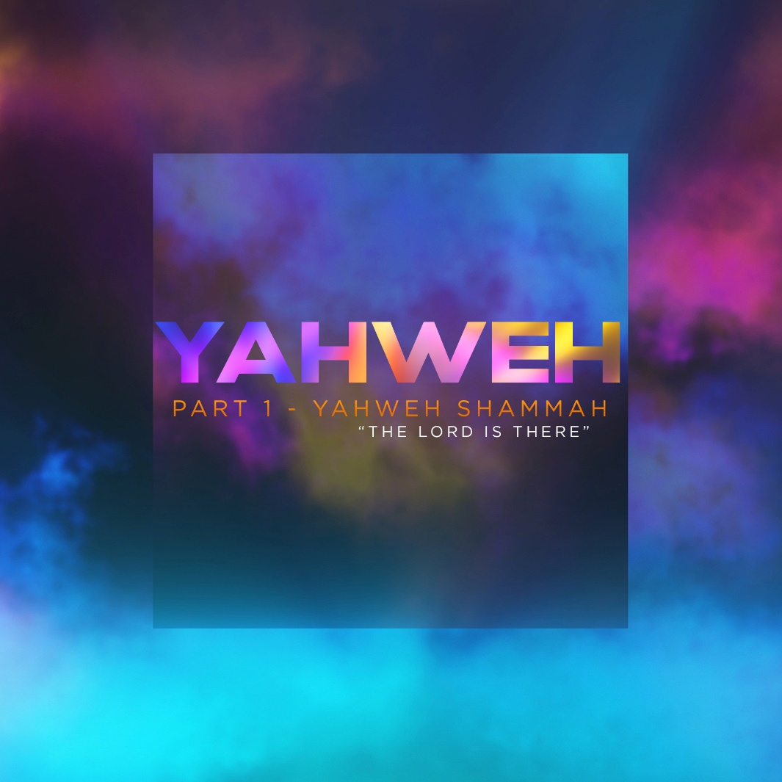

When it comes to God, there aren’t enough names to describe the wonder of who He is. The Bible teaches us that God is known by many names and each of those names reveals a different aspect of His character and nature.

Ezekiel 48:35 - “And the name of the city from that time on will be: “The Lord is there.” (NIV)

This passage concludes the revelations that the Lord gave the prophet Ezekiel. In this ending part of the message he had received from the Lord, Ezekiel speaks about the City of God. The remarkable thing about the vision of the City of God that Ezekiel saw was how the city would be called – The Lord is There, Jehovah (YHWH) Shammah. The name shows us a significant aspect of God’s nature – God is always present. The Lord is generally present everywhere but the essence of Ezekiel’s vision is the special presence of God in our lives that makes a difference in us.

Shammah is derived from the Hebrew word sham, which is translated as "there". Yahweh-Shammah is the name of God which means “I am the Lord who is there”. This is symbolic of the earthly Jerusalem. The name implies that God has not abandoned Jerusalem, even though it was left in ruins. God had promised restoration for Jerusalem.

YAHWEH-SHAMMAH

In the Book of Ezekiel, the prophet Ezekiel is speaking to an arrogant, proud people living with the memory of a covenant relationship with a God who had rescued them from oppression and slavery and made extraordinary promises about their place in the world and their future. God’s vision for Israel was so big. They had seen many mighty miracles, made them into a prosperous and peaceful nation, and were given a king to rule the world. But then it had all gone terribly wrong. Their sin and disobedience had led Israel into captivity, totally stripped of their belongings, and ethnically cleansed by Babylon and other nations.

As they wait in Babylon while being held in slavery, they cry, remembering Jerusalem, wondering how they could have gotten it so wrong. They are a long way from their homeland, alone, afraid, and held captive. Without a temple and a protected city, they are losing their identity, pride, and self-esteem. They have no hope. So, they think about home.

It reminds me of the parable Jesus told about the prodigal son who left his father’s house. The boy is a Jew sitting in a pigpen, ashamed, poor, hungry, and without identity. Deeply regretting the mistakes he had made, he had no hope and was thinking about home.

Have you ever thought, "I’m a mess."? Have you ever felt regret for a mistake you made? Have you ever had the feeling that you’ve lost everything? Are there times when you have no hope? When you feel a long way from home?

Ezekiel reminds the people of Israel: Wake up! The Lord is there! Ezekiel is prophesying about Jerusalem in the future where God’s presence will never leave. He is foretelling a REVIVAL and RESTORATION. God never wants to be the God over THERE, but instead the God HERE (wherever we are). Our God is not distant, removed and withdrawn, but rather, personal and intimate. I’m excited about this truth. Do you know why? God desires an authentic, sincere relationship with each of us. God wants us to know His presence, not for a moment, but for ETERNITY. It’s a message of hope, promise, redemption, and restoration. The reason why God sent His Son, Jesus Christ, is because He wanted to be with us forever.

WHAT DOES RESTORATION LOOK LIKE?

God picks up the broken pieces and uses them to make something more beautiful than before. I think of God putting all the fears, hurts, scars, pain, bruises, falls, bumps, and scrapes into His loving arms and hugging us back to our complete selves.

God is a rebuilder. And this happens on the inside first. Once the inside is repaired or rebuilt, it shows on the outside. This is surrendering my will to Him and allowing Him to restore me back to new, to be lifted on high as I humble myself before Him. A brand new chance to be the person He intends me to be. That’s what God is going to do for us.

We all carry the pain, shame, and regret over choices we’ve made leaving us battered and bruised. Or perhaps we carry a pain that is not a fault of our own because it is inflicted upon us by others. Either way, God wants to bring us renewal.
Rebuilding is the core of God’s relationship with us. He wants to renew all that is broken, hurt, or lost. God is our Redeemer. He reclaims and repairs our broken places. The growth takes place in the context of a relationship with God. We are CHANGED as we build a deeper connection with God and allow Him to TRANSFORM our lives. We are RENEWED as we allow God to heal our deep relational, emotional, spiritual, and physical scars.

There is not one situation that God isn’t capable of turning around. It doesn’t matter if our situation is hopeless. It doesn’t matter if we’re pushed to the edge with our difficult situation. We have to be firmly determined to move with full dependence on God. It takes intentionality for God to do the healing work. And this takes faith and patience.

Moving closer to God is the most life-giving choice we can make. We have to make a move. A small step may be what we can do at first. But that first move could be what God may have been waiting for us to make. Just show up to God! When we draw near to God, He welcomes us with LOVE and ACCEPTANCE. He sees and knows all our scars and imperfections, yet, He still cherishes us. It’s too beautiful to understand. But that’s who God is.

Wherever we are, whatever our circumstances or our need — GOD IS THERE. He is Yahweh-Shammah.

What will you do to move close to Him today so you can experience fresh renewal? Our God is already in your tomorrow. He already knows what your future looks like and He has complete control over it. God told the people of Israel in Jeremiah 29:11, “For I know the plans I have for you,” says the Lord. “They are plans for good and not for disaster, to give you a future and a hope.” (NLT)

THE LORD IS THERE! You cannot be in your future now, but He can. You can’t control the future events of your life, but God can. Yahweh-Shammah will walk with you into whatever tomorrow holds because of His great love for you. God is THERE in your tomorrow and in my tomorrow. He simply desires that we trust His heart. We have to trust Him fully.

God has promised His presence no matter what. Our lives are filled with good and bad baggage. We look back, around and ahead, fearing the unknown and worrying about potential disaster and through it all Yahweh-Shammah is there.
We cannot be in our future now, but God can. We can’t control the events of today but He can. Yahweh-Shammah will walk with you into whatever today and tomorrow will bring. And because of His great love, you can trust that He will never leave you nor forsake you.
Yahweh-Shammah - The Lord is There. Take a moment to reflect today. How has He been there for you?

LIFE GROUP DISCUSSION:
1) How has the Lord been there for you in your most difficult moment in your life?

2) What would you most look forward to if there was a reset button for all the mistakes you’ve made in life?

3) Have you ever said to yourself, "I'm a mess."? When did you say “I’ve had enough. I need God.”? What experiences led you to a renewed relationship with God?

