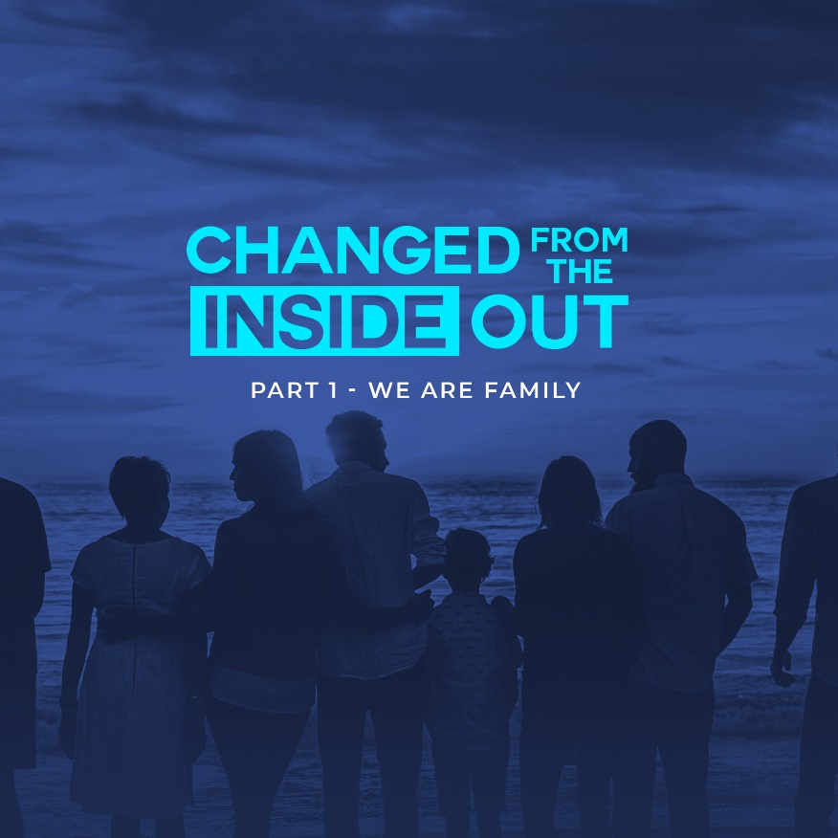

There are wonderful stories of people who were separated at birth because of adoption. Raised in different homes, they only find out their identity when they meet their real-life brothers and sisters. But what’s even more amazing is the incredible true story of how the spiritual DNA of our Heavenly Father renovates, shapes, and directs the lives of those who have different sets of mothers and fathers and yet are connected because of their faith in Jesus Christ. That’s the power of God. In WWCF-Cebu, our slogan is “Your family. Your home.” Because we are a family of God.

WHAT’S YOUR STORY?

What’s your story? Each of us has a story. Our story can be a powerful tool for God to use for His glory. Each person may have his or her own battle scars. A story of pain that is turned around for a purpose. A story of a life-altering situation that God miraculously accomplished. What I know from my knowledge and personal relationship with God, only God has the power to transform lives.

WORD

1 John 3:1-2 - “1 See how very much our Father loves us, for he calls us his children, and that is what we are! But the people who belong to this world don’t recognize that we are God’s children because they don’t know him. 2 Dear friends, we are already God’s children, but he has not yet shown us what we will be like when Christ appears. But we do know that we will be like him, for we will see him as he really is.” (NLT)

This family of brothers and sisters in Christ is more deeply connected to us than any other relationship, even our earthly families! We share a spiritual unity through our common Father, God! As God’s family, we are His arms and legs on this earth. From hugs and words of comfort to feeding hungry stomachs, we operate by the love of God to spread the love of God to all His people.

God chose us to be in His family. Paul wrote in Galatians 3:26 - it is through our faith in Jesus that we are sons and daughters of God. Our faith fuels our confidence and directs our steps, as we seek God first in our daily lives. Ephesians 2:10 - “For we are God’s masterpiece. He has created us anew in Christ Jesus, so we can do the good things he planned for us long ago (NLT).”

Our talents and abilities are no accident. Your talent in singing and playing instruments, your ability to counsel people, to welcome and usher in people to the church, and your gift of service and leadership are no accident. Even just showing up and worshiping with us here in the church is already a gift, a gift of encouragement to strengthen our church family. When we work diligently with the gifts God has given us, we are able to become a channel of love to reach out to others. We experience God’s love to the fullest, without a barrier caused by sin.

The church meets to worship God and pray to Him together. We gather to support and encourage each other, because the work of the Lord, though joyful, is difficult. It takes everyone’s talents and collective contributions to accomplish the purposes of God. “For we are God’s fellow workers,” 1 Corinthians 3:9 says, “For we are both God’s workers. And you are God’s field. You are God’s building.”

THE PURPOSE OF GOD’S FAMILY

Ephesians 1:3-5 - “3 All praise to God, the Father of our Lord Jesus Christ, who has blessed us with every spiritual blessing in the heavenly realms because we are united with Christ. 4 Even before he made the world, God loved us and chose us in Christ to be holy and without fault in his eyes. 5 God decided in advance to adopt us into his own family by bringing us to himself through Jesus Christ. This is what he wanted to do, and it gave him great pleasure.” (NLT)

If you are a disciple of Jesus, you have two families. The first one, the family of origin, is the one you were born into. You had no control or choice in this matter. Your family of origin may have been very nurturing, or it may be dysfunctional. Either way – your family of origin is fixed and cannot be changed. However, when you are born again through Jesus Christ, you inherit a new family – the family of God.

God’s church is supposed to be a group of people in a relationship who do life together. Relationships are important because the gospel gets lived out within these relationships. Real life can be lived out when we stay or remain in relationships with each other. This is where we learn to use and put into practice the Fruit of the Spirit that God has placed within us.

God calls His Church the family of God. The early church met together in the temple courts, but also met together in homes where they were devoted to deep, continuing relationships. They became a spiritual family. In Acts 2:42, we see them displaying many of the characteristics of a family. They ate together, shared their possessions, and even sold their possessions if needed to take care of each other. They focused on the Word of God and the teachings of the apostles.

These actions not only picture the attitudes and actions of a family, but these are also the kind of bond and relationships that develop in a life group or small group. The life group is a place where people can be relationally discipled as part of a spiritual family.

Paul reminds us in Romans 12:2 not to conform to the world. God created the earth, us, and everything in it. However, we are warned against gelling or conforming to the

patterns of this world. The purpose of God’s family is transformation, a slow and steady purification to conform our hearts to Christ, as we were created, designed, and purposed.

We change daily as we follow Christ. As the local church movement for Christ grows, it isn’t just individuals who change, but communities. The purpose of God’s family is to move and go on account of the Gospel, not just preaching the word, but acting in love, reflecting the love of our Savior Jesus.

THE ACTS OF GOD’S FAMILY

Romans 8:15 - “So you have not received a spirit that makes you fearful slaves. Instead, you received God’s Spirit when he adopted you as his own children. Now we call him, “Abba, Father.”” (NLT)

Power, love, and self-control. This is the countenance of God’s children. God’s church, His family, is to do right by each other, and others. Goodness is the goal. Billy Graham is quoted as saying, “Amazing things can happen when the family of God bands together.” We’ve been shown grace and mercy by Jesus Christ, and in Him we are able to allow His grace and mercy to flow out of us to the people God has placed in our lives.

YOUR PART IN GOD’S FAMILY

John 3:16 - “For this is how God loved the world: He gave his one and only Son, so that everyone who believes in him will not perish but have eternal life.” (NLT).

Jesus was the greatest expression of love of all time. God the Father sent His Son for us, fully human and fully God, to make a way for us to stand in His presence, to become a part of God’s family. Jesus chose to sacrifice His life out of love for us.

“I am the way, the truth and the life,” Jesus declared in John 14:6, “No one comes to the Father except through me.” God made a way for us to become adopted sons and daughters through Christ. When we choose to believe in Christ, we become heirs of His Kingdom. This is one of the first memorized King James versions I learned in high school in my former Baptist Church. I will read to you the NLT version Galatians 2:20- “I have been crucified in Christ. It is no longer I who live, but Christ who lives in me. And the life I live in the flesh by faith in the Son of God, who loved me and gave himself for me” (NLT).

INVITATION TO GOD’S FAMILY

Mark 12:30 - “And you must love the Lord your God with all your heart, all your soul, all your mind, and all your strength.” (NLT) We lead others to God by example and invitation. When God is our first priority, our lives reflect His love. Our families and homes exude the love and grace of our Heavenly Father. Inviting others into the family of God requires us to lean in and listen for His lead.

This isn’t the way the world behaves. It’s not how our social media feeds read. So, when people witness this type of behavior, which flows not from anything we do, but from Christ in us, their hearts are naturally inclined to ask where our hope comes from.

We may belong to the family of God here on earth, “but our citizenship is in heaven.” Life was never promised to be easy, but Jesus will undoubtedly return to make all things right. This is ultimately what it means to be in the family of God. We put our hope, not on earthly things, but in the things of heaven, the promises of our great God … of which not one has ever been broken.

Our joy remains through the toughest of times, not with a plastic painted-on smile, but a deeply rooted joy. Through it all, we “search for the Lord and his strength; we continually seek him.” knowing He hears us, loves us, answers us, and has good plans for our lives.

LIFE GROUP DISCUSSION:

1) What’s your story? How did you become part of God’s family?

2) How should knowing our identity as children of God change our attitudes? Our actions?

3) Why is it important to be involved in a local church? What are the benefits of being part of God’s family (being involved in a local church community)?

