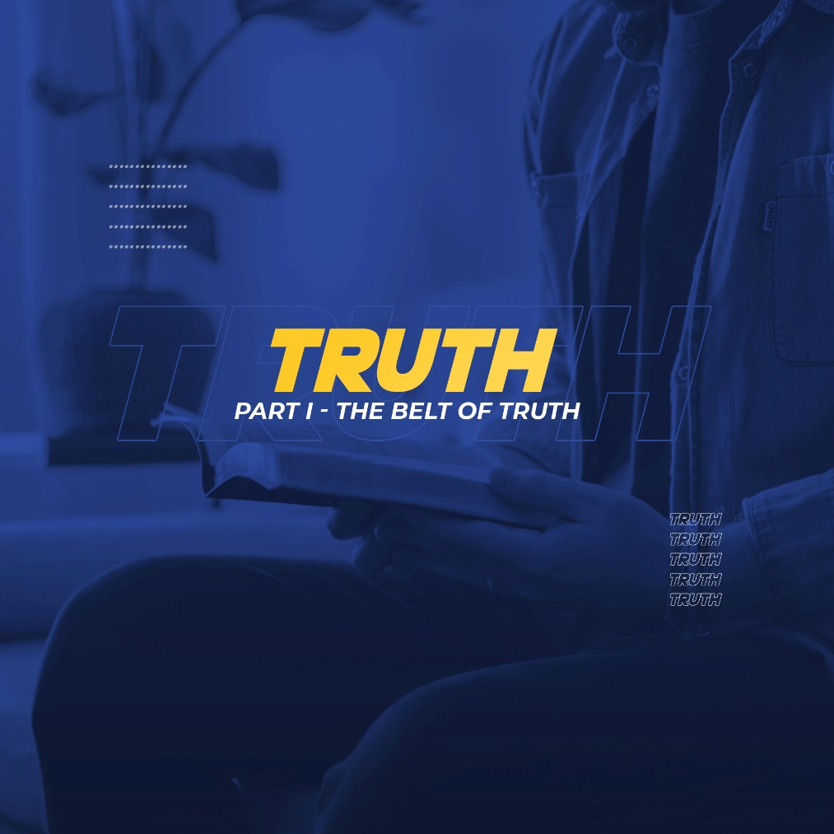

Many people wonder what happened to the world today. The world is so messed up. We're living in a world of confusion, chaos, and lies. We're living in a day and are paying the price tag for the suppression of truth. We don't know what the truth is. What's up is down, what's down is up. What's right has become wrong, what's wrong is deemed as right, all in the name of popularity, in the name of personal preference, in the name of man's desire to be independent. In my opinion, the beginning of our REJECTION OF TRUTH is where all the mess around the world started.
Over time, we have come to reject the concept of truth. Today, people don’t talk so much about what is true and what is false. They talk about what works, or what’s true in my definition and what’s true in your definition. Anyone who declares to have the truth is branded as biased or critical or discriminating or self-righteous, while doubt, uncertainty or not being sure are considered virtues or character.
This, in my opinion, is a big reason why our world is such a mess. And it’s not accidental. The battle for truth has been going on for years. John 8:44 - “For you are the children of your father the devil, and you love to do the evil things he does. He was a murderer from the beginning. He has always hated the truth, because there is no truth in him. When he lies, it is consistent with his character; for he is a liar and the father of lies.” (NLT)
Two of the devil's most powerful tools are DECEIT and LIES. What do you mean by deceit? It could be dishonesty, cheating, or hypocrisy. Anything that doesn't tell the truth. Most of our issues and setbacks in life aren't only the result of our weakness or ignorance; rather, they are the result of our decision to tell lies rather than tell the truth. We often choose to believe a lie instead of believing the truth.
It’s also the reason truth is one of the most important pieces of the armor of God. This morning, we’re going to talk about this first line of defense we need to stand against the devil: The belt of truth, described in Ephesians 6:13-14 - “13 Therefore, put on every piece of God’s armor so you will be able to resist the enemy in the time of evil. Then after the battle you will still be standing firm. 14 Stand your ground, putting on the belt of truth and the body armor of God’s righteousness.” (NLT)
THREE REASONS WHY THE BELT OF TRUTH IS AN IMPORTANT COMPONENT OF PROTECTION:
The Belt of Truth Holds Everything Together
Why was the belt used as a symbol of truth? First, Truth holds together WHO YOU SHOULD BE and WHO YOU ARE. The word we use is INTEGRITY. A person who wears the belt of truth is sincere and does not represent himself as one thing while actually being another. He doesn't just avoid telling lies; he also avoids living them. A Christian can’t be a saint in the church and be a devil in the office or at home. Although he has faults, he should try his best to live a blameless, steady, dependable, and honest life.
Second, Truth holds your life together with the truth of the Scriptures. Wearing the belt of truth is not just being honest, but knowing and believing the truth of the Word of God. God’s Word is the standard by which all truth is measured. We can use different benchmarks in relation to business standards whether it be in accounting or investments or inventory. We can use different standards in raising our kids. But…The only benchmark for truth is God’s word. The Bible tells us that KNOWING THE TRUTH means KNOWING CHRIST as the SOURCE OF TRUTH, from which all other truth flows.
Anything which contradicts or disagrees with the truths of the Bible is not true. Apart from the truth of God’s Word, you cannot distinguish truth from falsehood. If you don’t wear the belt of truth, the devil will make sure you get caught with your pants down.
If you don’t pursue a life of integrity, the devil will defeat you by exposing you. Listen to this: The devil will expose your hypocrisy so people lose faith not only in you but also in God. There is nothing hidden that will not be disclosed, and nothing concealed that will not be known or brought out into the open. The devil will expose your lies so nobody trusts you. Lying always backfires, it always ends up making things worse, not better. The devil is an expert not just in telling lies, but in using lies to do as much damage as possible. How many marriages or friendships or churches have been destroyed by lies? And the problem is: People don’t listen to two sides of the story. That’s how the devil uses lies to work.
Put on the belt of truth and never take it off. Pursue integrity, live what you preach, tell the truth, even when it’s inconvenient or painful. This is how you stand against the devil.
The Belt of Truth Strengthens You
The belt of truth gives you the courage to stand against the attacks of the devil. Truth emboldens you with the courage of a CLEAN CONSCIENCE. Liars are cowards. They‘re always afraid of being found out, always afraid the truth will come back to haunt them, always afraid the truth will end up hurting them.
When you’re on the side of the truth, you don’t have fear in you. They can do all they want, but there’s no fear in you. You have confidence that comes with integrity, that as long as you tell the truth and live the truth, you have nothing to fear.
In addition, Truth emboldens you with the courage of CONFIDENCE. When you know the truth, you have something to believe in, something that defeats your doubts. Truth conquers your fear. Truth stands the tests and trials of time, an anchor that helps you stand strong no matter how everything else crumbles around you. A Russian proverb says: “One word of truth outweighs the whole world.”
The only truth we can be absolutely certain about is the truth of God’s Word. This is courage born in the certainty of our faith in God and His Word, the courage that fills the heart of Moses standing before Pharaoh, the courage that fills the heart of David running toward Goliath, the courage that strengthens our Lord Jesus as He prays in the Garden of Gethsemane and hangs on the Cross.
Wearing the belt of truth means having a backbone! Some Christians are afraid of standing for the truth. They want to please everybody except God. In the name of tolerance, they stay silent when they should speak up, sit down when they should stand up, and back down when they should hold their ground. This is why the minority nowadays have louder voices than the silent majority - Christians.
It is unfortunate that the people who know the truth don’t want to talk. And the ones who don't have a clue, don’t want to shut their mouth. I know it can be hard to tell the difference sometimes, but when the line in the sand is drawn, I think it’s better to fall on the side of courage than on the side of fear.
Knowing and living the truth, being sure of the truth of God’s Word, makes you bold as a lion, brave enough to stand against the lies of the devil.
The Belt of Truth Prepares You for Action
The belt of truth is not just about what we think and believe. The belt of truth influences our thoughts and beliefs and it motivates us to take action. 2 Timothy 2:15 - “Work hard so you can present yourself to God and receive his approval. Be a good worker, one who does not need to be ashamed and who correctly explains the word of truth.” (NLT)
The truth always calls for action. James 1:22 - “But don’t just listen to God’s word. You must do what it says. Otherwise, you are only fooling yourselves (NLT).” The truth of God is put into action through thoughtful, humble obedience. The truth that’s never put into action doesn’t do much good. It tends to feed your pride, to make you superior and self-righteous.
But the only way you and I can stand against the lies of the devil is by doing something with the truth God reveals to us. Standing against the devil requires not only believing the truth but practicing the truth - living your whole life in light of the truth. You cannot stand still and stand against the devil. You must wear the belt of truth by applying it and acting on it.
However, if you don’t accurately apply the truth, you end up an instrument of the devil in the name of God. You confuse the truth with your own biases and preferences, too stubborn to admit you might be wrong. You argue about things on which the Bible says nothing, or you speak up for yourself more than they speak up for the truth.
Satan’s main strategy is pretty simple. He makes truth look like lies and lies look like truth. This is why he is called the Father of Lies. But here’s the thing; he doesn’t just want us to believe his lies ourselves. That’s just the beginning. His ultimate goal is to get us to live out the lies in our own lives and tell them to others so they can start living and spreading the lies themselves.
We each have a choice to make. Putting on the armor of God means dedicating ourselves to the truth and trusting God to guide our steps along the way. So, I’m telling you now, you must choose your side. You can let the devil deceive you and defeat you. You can swallow his lies like a fish swallows the bait on the hook, and in the end, you will die. Or you can stand against the devil by wearing the belt of truth, the belt that holds everything together, that strengthens you, that motivates you into action. The lies of Satan and this world and your own heart will put you in chains and make you a slave. But Jesus’ promise is still just as true right now as it was when He first said it.
John 8:31-32 - “31 Jesus said to the people who believed in him, “You are truly my disciples if you remain faithful to my teachings. 32 And you will know the truth, and the truth will set you free.”” (NLT)

REFLECTION QUESTIONS:
- Are Jesus' life and teachings the ultimate standard by which you determine what is truth in the world, in your life, and in your situation? Share an experience where you took a stand for God in the Bible.
- Share about a time when you chose your way instead of God. What happened?
- Does being truthful require sharing your every thought? Why or why not?

