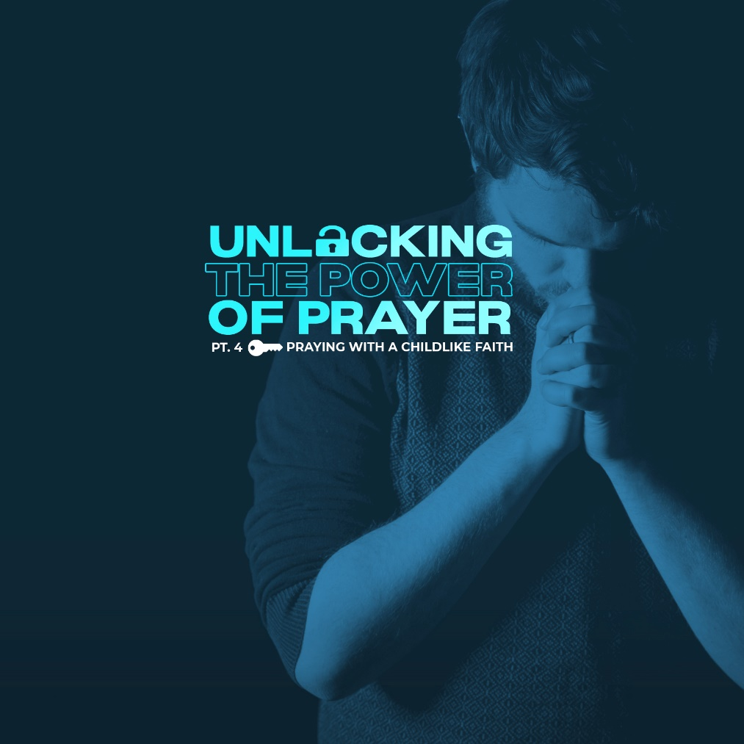

What is childlike faith? Is this the key that would unlock the hand of God when it comes to prayer? Adults often correct children because they think that the way kids are doing it is wrong. But let us look at some verses where Jesus told us to follow the ways of a child.

Matthew 18:4 - “Therefore, whoever takes the lowly position of this child is the greatest in the kingdom of heaven (NIV).” Mark 10:15 - “Truly I tell you, anyone who will not receive the kingdom of God like a little child will never enter it.” (NIV)

Jesus is not looking for a religious FORM. He’s looking for childlike FAITH. That is what impresses Jesus. And it’s the same with our prayer life. God is not impressed with how FANCY our prayers are. He’s impressed when we FAITHFULLY trust Him like a child as we pray.

When Jesus taught His disciples what we call the “Lord’s Prayer,” it was because the disciples were worried about form. They said to Him: “Lord, teach us to pray (Luke 11:1)!” They were asking Jesus to give them a formula for successful prayer. They wanted to “do it right” because they felt if they didn’t do it right, then, God wouldn’t hear their prayers.

So, how do we turn and become like children while still trying to grow and mature in our faith? We look at how children conduct themselves! Children tell their parents everything. Have you ever noticed how much kids love to talk once they get going? They tell stories about their days, talk about their friends, share what they created in school, and openly unleash their emotions. They tell their parents everything and they don’t worry about how they sound when they do it. Do you pray in this way?

If we are to humble ourselves and become like children before our Father in heaven, then we will pray as children speak to their parents. We can come to God like he just picked us up from school and joyfully asked how our day went. And while sometimes earthly parents are more preoccupied with other things to be fully engaged and listening to their children, God is always fully engaged in prayer with us. It’s usually we who are preoccupied with other things as we pray to our Father.

► ADORATION

First, we express our adoration or honor to God. Matthew 6:9 - “Our Father in heaven, hallowed be your name (NIV).” What’s that all about? It’s all about realizing WHO it is you’re talking to. of people. Real prayer is about talking to God, not someone else. And Prayer is not just talking to GOD, it's talking to our FATHER. Now, even the best of earthly fathers can fall short, but God is a FATHER the way real fathers ought to be. Jesus talks about that kind of father when he said in Matthew 7:9-11 - “9 “Which of you, if your son asks for bread, will give him a stone? 10 Or if he asks for a fish, will give him a snake? 11 If you, then, though you are evil, know how to give good gifts to your children, how much more will your Father in heaven give good gifts to those who ask him!” (NIV)

In other words, when you pray, you are not talking to an uncaring, uninterested, indifferent God. We pray to the God of the universe “Our Father in heaven.” The God who created all things by just speaking it into existence. He has power beyond anything we can even begin to imagine. Romans 8:32 says, “He who did not spare his own Son, but gave him up for us all—how will he not also, along with him, graciously give us all things?” (NIV)
If He'd give His son to die for our sins, what else do you think He'd be willing to do? The problem with us adults is that we tend to DOUBT that God cares. And we even DOUBT God will do anything. Children don’t have that problem. You tell them that God hears their prayers, and they pray. You tell them God cares and that God can do anything, and they believe it.

► CONFESSION

What would we be confessing? Our sins, right? How many of you have sinned? Me too. Have you ever felt you’ve messed up so bad, or you’ve done, or thought, or said something that shamed you so much that God wouldn’t listen to you? That’s why God told us: 1 John 1:9 - “If we confess our sins, he is faithful and just and will forgive us our sins and purify us from all unrighteousness (NIV).” Confession solves our guilt. Confession removes our shame. That’s God’s promise, a promise we can accept with childlike faith.

► THANKSGIVING

If you miss out on the THANKSGIVING part of your prayers, there will be no JOY in your praying. Philippians 4:6-7 - “6 Do not be anxious about anything, but in every situation, by prayer and petition, with thanksgiving, present your requests to God. 7 And the peace of God, which transcends all understanding, will guard your hearts and your minds in Christ Jesus (NIV).” Did you catch that? If you focus on thanksgiving in your prayers, you’ll have peace from God that doesn’t even make sense. It’s illogical. It’s irrational. It goes way beyond anything you’d expect, but it happens anyway.

Think about it for a moment: When you flavor your prayers with Thanksgiving, what are you thanking God for? You are thanking God for what He has already done in your life, right? You are remembering the times when God DID CARE and the times God DID DO something in your life. When you give thanks to God in prayer, you are calling to mind God’s faithfulness. We have a Father who is faithful. We have a Father who cares about us. We have a Father who can do whatever He wants to do.

► SUPPLICATION

Philippians 4:6 says, “Do not be anxious about anything, but in every situation, by prayer and petition, with thanksgiving, present your requests to God (NIV).” God has NO problem with us presenting our requests. He’s NEVER had a problem with that. It doesn’t offend Him when you ask Him for anything.

Jesus said, Matthew 7:7 - “ASK and it will be given to you; SEEK and you will find; KNOCK and the door will be opened to you (NIV).” Just ask!!! Can God say “NO”? Of course, He can. He’s God. He’s sovereign. But here’s my question to you: Would you be any worse off if God said "NO" or when He didn’t give because you didn’t ask?

So ask. Ask big. If the answer would be too big for you to handle, God won’t give you everything you ask, but He will hear. And He will be honored by your faith. And He might just give you part - if not all - that you ask. So ask. You're not going to offend Him.

But when it comes to prayer, a lot of Christians don’t ask. How come? There are a couple of answers to that. First, there are people who believe God’s going to do what God is going to do anyway, so why bother. According to a survey, 85% of people who pray regularly do not expect to have their prayers answered. They don’t have the childlike faith to believe God cares for them to answer their prayers.

Another problem for many Christians is that they don’t ask because they don’t want to bother God. Sure, they're troubled by something in their lives, but it’s not that big a deal. They can take care of things themselves. They want to save their prayers for the “big stuff”.

There is nothing you could ask in prayer that would bother God. Imagine, Jesus even taught us to pray to God to give us our daily bread. What is more basic than bread? You don’t get any more basic than that. So pray to God. Here’s something more: If it’s big enough to bother you, it’s big enough to pray about.

If we are to treat God as children treat their parents, no time or subject is off limits. We won’t worry about how we sound or what subject we choose to discuss. We won’t worry that we sound stupid or immature. We won’t worry about judgment coming our way. We will just talk when something comes up. It’s almost as if our thoughts become prayers. We share it all with our Father in heaven because he cares about it all.

Children go to their parents when they need comfort. When children get hurt, all they want is to be comforted by mom or dad. When they have a bad day at school, it seems that only mom or dad has the ability to bring them the comfort they need. Children don’t worry about bothering their parents with their problems. They run to their parents for comfort. They run in fear, confusion, hurt, sickness, and disappointment. They don’t hold back their tears for fear that what they are dealing with is too much for their parents to handle.

This is precisely why Jesus calls us to come to Him like children, not teenagers or adults. Children are flawed, messy, emotional, dependent beings and they willingly run to their parents just as they are. Will you do the same with God?

LIFE GROUP DISCUSSION:
1) Where do you struggle in trusting God? What area of your life is not producing the fruit of his goodness, reality, and love for you?

2) When situations come up that you do not understand, do you show a childlike trust and dependence on our Heavenly Father? How?

3) This sinful and broken world can bring an end to our child-like qualities. Jesus is asking us to bring them back to our lives. Which ones do you want to prioritize in your life?

