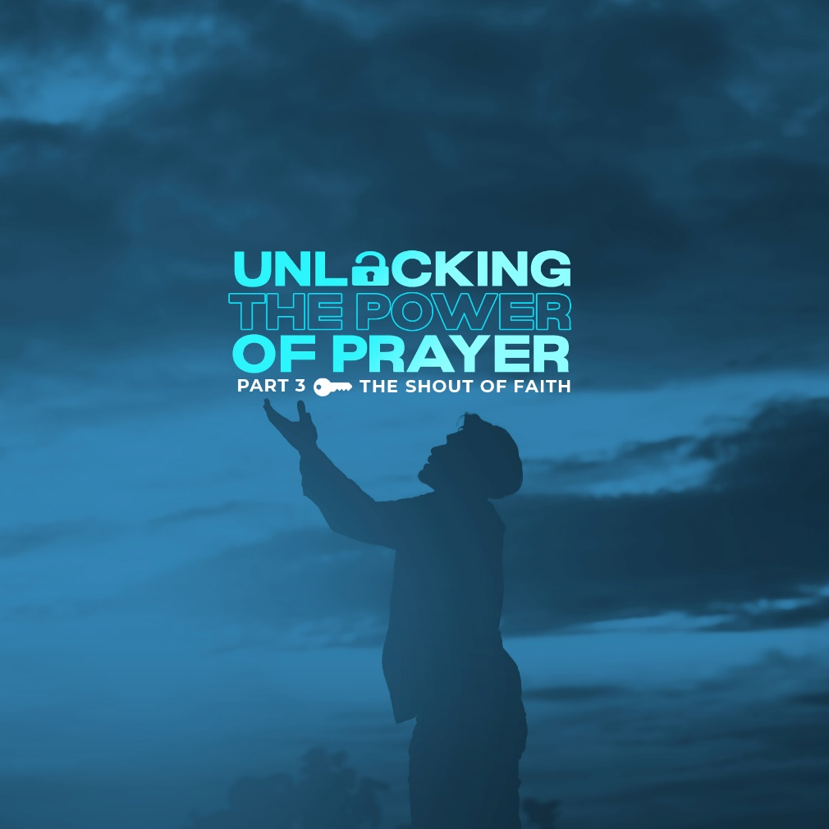

We very often connect prayer with crises in our life. Instead of prayer being something we do everyday like breathing, eating, walking, and talking, it seems to have become like that glass-covered box on the wall that says, "break in case of emergency."

How do you look at prayers? Do you pray bold prayers? Or are you the shy type, hesitant to ask God for something? What if you have a desperate longing in your heart? A petition that you knew was too great for any earthly fulfillment, but that must be carried to the cross, again and again? Do you break the glass in case of emergency or do you press in hoping that one day that desire, that longing will come to pass?

► WORD

Mark 10:46-52 - “46 Then they came to Jericho. As Jesus and his disciples, together with a large crowd, were leaving the city, a blind man, Bartimaeus (which means “son of Timaeus”), was sitting by the roadside begging. 47 When he heard that it was Jesus of Nazareth, he began to shout, “Jesus, Son of David, have mercy on me!” 48 Many rebuked him and told him to be quiet, but he shouted all the more, “Son of David, have mercy on me!” 49 Jesus stopped and said, “Call him.” So they called to the blind man, “Cheer up! On your feet! He’s calling you.” 50 Throwing his cloak aside, he jumped to his feet and came to Jesus. 51 “What do you want me to do for you?” Jesus asked him. The blind man said, “Rabbi, I want to see.” 52 “Go,” said Jesus, “your faith has healed you.” Immediately he received his sight and followed Jesus along the road.” (NIV)

► GET TO KNOW BARTIMAEUS

The Bible describes Bartimaeus as a blind beggar. Here he is, dependent on people, ignored, worthless. There is nothing worth living for him. He has gotten used to this kind of life, existing but not living, present but misrepresented, alive but not full of life. This identity got stuck with him. No man ever wants to go near him. Nobody cares except Jesus.

► FAITH BELIEVES

For obvious reasons, he did not come to know Jesus because of what he saw. Jesus had worked many miracles. He had cleansed the leper and healed the lame, the deaf, and the blind. He had healed the woman with the issue of blood. Bartimaeus had not seen any of these miracles. He was shut up in his world of total darkness as a blind man. So, how did he come to faith?

Bartimaeus may be blind, but his ears were working very well for him. We can imagine that since Bartimaeus was a beggar, he would go where there were people. There he would hear people talking about Jesus. Bartimaeus would stop them and ask them the news, and they would tell the story. Hope was born in his heart. If you’re in a hopeless situation, let your faith in God give you hope again.

Day after day, Bartimaeus would sit by the roadside. He would call out to people and ask them to tell him repeatedly about Jesus. And people would say to him the story, confirming the truth of what Jesus had done. Again and again, Bartimaeus would listen intently with a smile of hope. Day after day, he would sit alone on the roadside, turning the story over and over in his mind, imagining that he was the one whose eyes had been opened and what it would be like to see. And as Bartimaeus was sitting on the roadside, he heard the noise of the approaching crowd. “Jesus of Nazareth is passing by.” That was enough for blind Bartimaeus. He had already concluded that Jesus was the promised Messiah, anointed and sent to proclaim recovery of sight to the blind. Others without faith would have said, “Jesus? He must be busy. He has no time for me. There is no hope for me. This is the way I’ve always been. Things will never change for me.”

God is never busy for those who are desperately praying in faith. The crowd could have been a reason for letting the chance pass Bartimaeus by, but the crowd became his reason to cry out with all his strength. UNBELIEF would have shut the mouth of Bartimaeus, but FAITH opened it wide as he called out, “Jesus, Son of David, have mercy on me!”

How many times has Christ not only passed you by, but also knocked at your door, and called out to you? Time and again He has invited you. The poor blind beggar did not have the encouragement and invitations that you have had. Bartimaeus did not have multiple opportunities to call upon Jesus as you have had, yet he did not waste the one opportunity he received. How many times have you heard God’s message? How many times have you heard Christ calling to you? How often have you been invited to surrender your life to the One who died for you?

► FAITH SHOUTS

Mark 10:47-48 - “47 When he heard that it was Jesus of Nazareth, he began to shout, “Jesus, Son of David, have mercy on me!” 48 Many rebuked him and told him to be quiet, but he shouted all the more, “Son of David, have mercy on me!”” (NIV)

No amount of rebuke or opposition could shut up Bartimaeus. He was determined. He was desperate. He had no other hope. That is what faith looks like. If you want a miracle or you want to be saved, your call to Jesus must be one of desperation. Bartimaeus did not repeat some sinner’s prayer. He was not quoting some memorized prayer. His prayer was the cry of his heart. True prayer has fire inside. It shoots up toward heaven and finds its way to God.

When you desire for God to hear you, you have to persevere in prayer. Desperate prayer never stops. This man’s prayer was simple. He did not find his prayer in a prayer book. Words were not flowery. The words that came from his lips were first formed in his heart. They expressed his deepest desire for mercy.

Jesus will not ignore the earnest cry for help. He stops. He looks around. He sees a man who cannot see Him. Mark 10:49 - “Jesus stopped and said, “Call him.” So they called to the blind man, “Cheer up! On your feet! He’s calling you.”” (NIV) Did you know what Bartimaeus did? He threw off his coat, jumped up, and came to Jesus. My friend, did you not hear Jesus when he called you? He said in Matthew 11:28 - “Come to me, all of you who are weary and carry heavy burdens, and I will give you rest.” (NLT)
Do not think that God is not calling you. He calls all who are weary. He calls all who carry heavy burdens. He calls all who are overwhelmed with sin. He calls all who are thirsty for true life. He is calling you.

► FAITH RESPONDS

Mark 10:50 - “Throwing his cloak aside, he jumped to his feet and came to Jesus.” (NIV)

When Bartimaeus was finally noticed by Jesus, it changed his whole identity. From the hundreds of people Jesus passed by, this blind man caught His attention. Excited to meet Jesus personally, Bartimaeus got up and left his cloak. Why did Bartimaeus leave his coat? By faith, he knew that he didn’t need his coat anymore. He knew that meeting Jesus personally would give him a new identity. A total makeover.

This identity represents us. When Jesus calls us, He asks us to throw off our old lives and anything that might keep us from obeying Him wholeheartedly so that we will not be entangled by our old lives. In this manner, throwing the robe away was symbolic of Bartimaeus' desire to present himself to Jesus in complete abandonment of his former life to his now Lord and Savior.

Throwing aside the cloak is a literal decision to no longer rely on anything that we may have been identified with (security, status, wealth, education, nationality) as we come face-to-face with Jesus. The only identity that remains when we throw off our old identity is the greatest identity we will ever be proud of: We carry God’s name and that we are His.

Throwing off his cloak was an act of faith. The robe was Bartimaeus’ source of food and living. But he believed that he would no longer need his cloak to collect alms and trusted that Jesus would heal him. His faith was so sure that he quickly discarded the robe, his source of security, and his closest tie to any hope of survival, as he went to Jesus, confident in the healing that was to come.

F Is God telling you to let go of something in your life so He can grant you your prayer request? What sin do you have to throw off in order to show Jesus that you are serious with your faith? Our willingness to trust Jesus for a better future and our choice to throw away something that has been most valuable to us in exchange for a life with Jesus is the ultimate act that we will ever do, all for complete faith and devotion to Jesus.

► CONCLUSION

From among the people who desired to be healed at that time, Bartimaeus grasped who Jesus was. From the little information that he had about Jesus, he took all the information to heart. There was no stopping what he knew of Him. The Jesus that he knew was the true Son of God.

Bartimaeus persisted despite hindrances. Crowds were pressing in. He couldn’t get hold of Jesus so he had to get Jesus’ attention by shouting. Jesus knew a shout of faith. This was the only way Bartimaeus could catch His attention so that total healing of body and soul could take place.

LIFE GROUP DISCUSSION:
1) How did the message encourage or challenge you today?

2) Do you sometimes doubt that your prayers may not be answered? What are the hindrances that block you from fully believing that God can perform miracles for you?

3) If Jesus sat down next to you today and asked, “What do you want me to do for you?” How would you answer Him?

