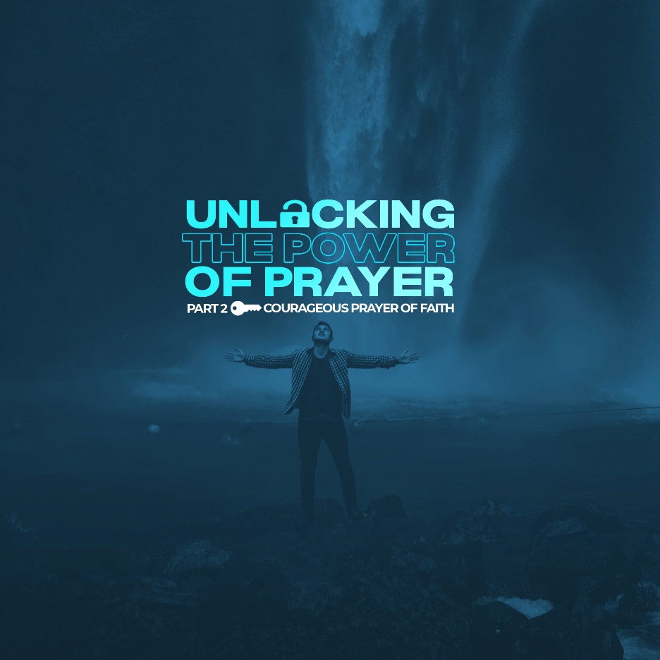

Bravery lets you do things you wouldn't know you are capable of doing. It lets you face your fears and overcome them. It gives you the courage to do the impossible to get the miracle or result you wanted. Are you brave enough to face your fears and fight off whatever is causing your fears? Let’s journey into the story of this woman who mustered up the courage and faith, all because she needed a miracle.

► WORD

Mark 5:24-34 - “24 A large crowd followed and pressed around him. 25 And a woman was there who had been subject to bleeding for twelve years. 26 She had suffered a great deal under the care of many doctors and had spent all she had, yet instead of getting better she grew worse. 27 When she heard about Jesus, she came up behind him in the crowd and touched his cloak, 28 because she thought, “If I just touch his clothes, I will be healed.” 29 Immediately her bleeding stopped and she felt in her body that she was freed from her suffering. 30 At once Jesus realized that power had gone out from him. He turned around in the crowd and asked, “Who touched my clothes?” 31 “You see the people crowding against you,” his disciples answered, “and yet you can ask, ‘Who touched me?’” 32 But Jesus kept looking around to see who had done it. 33 Then the woman, knowing what had happened to her, came and fell at his feet and, trembling with fear, told him the whole truth. 34 He said to her, “Daughter, your faith has healed you. Go in peace and be freed from your suffering.” (NIV)

► THE BACKGROUND OF THE SICK WOMAN

Here is this poor, sick woman. For twelve years, she suffered a constant flow of blood. It has made her unclean, preventing her from worshiping in the temple. She’s a social outcast. Even if she was once well-to-do, she’s flat-broke from doctor bills. She’s tried all medicine has to offer and suffered not only from the disease but also from the cures. She’s at the end of her rope. And as she sits in the street, she sees the crowd coming her way, and Jesus whom she’s heard about is there, healing and performing miracles. She thinks, “He is the answer to my prayers. He is my last chance. My only solution. He can help me.”

Here she is, weak and out of options, but just strong enough to come, which is all the strength Jesus requires. That’s what Jesus asks of us. As this woman makes her way through the crowd, everyone she touches becomes unclean. Then she reaches out her hand, touches the edge of Jesus’ clothes and something happens.

Lots of people touched Jesus that day and nothing happened. Proximity doesn’t change things. Just being around Jesus isn’t enough. A lot of people think it does. A lot of people think closeness to Jesus, closeness to the church, and closeness to other Christians are enough. Like the holiness just rubs off. But it doesn’t work that way. Closeness isn’t enough. There is a way of touching Jesus without really touching Him. There’s a way of touching Jesus without receiving His power. A lot of people touched Jesus that day in that crowd, but only the woman got His power after the touch.

► THE COURAGEOUS PRAYER OF FAITH

So, what unlocks Jesus’ power? Just this: The personal need for a Savior and the courageous prayer of faith.

That’s all this woman had. And that’s all she needed. So many in the crowd that day were just excited about what Jesus might do for others. This woman was desperate for what Jesus could do FOR HER. That’s the difference. It’s the difference between seeing Jesus as a STAR or personality to watch and seeing Jesus as Savior. Until you understand your personal need for Jesus, His power will be withheld from you. But when you come to the end of your rope, when you come to Jesus with empty hands of faith, desperate for salvation and answered prayer, His power races toward you.

To get to Jesus she had to get past the roadblocks. She had to get past the possibility of rebuke, she had to get past the possibility of being identified, and she had to get past the possibility of being discriminated against. So many hindrances. But this truth shouts: what is not possible with men, is possible with God. When she touched the hem of Jesus’ clothes, Jesus noticed it. A touch of faith could not be hidden from God. A touch of faith could not be ignored by God. It was not the touching that healed the woman. It was, says Jesus Christ, the touch of faith that made her whole.

► CONFESSION BRINGS HEALING

Why was she afraid? Here she is, an unclean woman, a social outcast, speaking up in front of all these men. But that wasn’t the true depth of her fear. She was face to face with Jesus, with God.

She knew who she was. And she knew who Jesus was. What would He do to her? Isn’t that a fear inside us all? Don’t we all fear what God will do to us in those moments when He’s calling us to confession? When He wants us to tell Him the truth about us? We’re thinking: “Will God turn me away? Will God punish me?” And then she comes. Mark 5:33 - “Then the woman, knowing what had happened to her, came and fell at his feet and, trembling with fear, told him the whole truth.” (NIV)

What did she tell Jesus? Probably, everything that happened to her. She told of all her struggles, all her pain and suffering, all her feelings of shame and despair, and all her attempts at finding a cure. She talked about seeing Him, coming to Him, touching Him, and trusting in His power to help her. She told it all. She probably said more. And there were things she didn’t say that Jesus knew anyway. No wonder she trembled! This was a costly confession, which is really the only true kind of confession.

There’s a lesson here for us. Jesus is not a genie. He is not there to give us what we think we need. He’s there to give us what He knows we need. But to give us that, He’s going to ask a lot of us. He’s going to ask more of us than we planned on sharing. He’s going to ask for brutal honesty. Why? Because brutal honesty is the only freeing kind of honesty. The only way you ever have the assurance of faith you need is if you tell Him your whole truth. And when you do, He responds.

Look at verse 34. Mark 5:34 - “He said to her, “Daughter, your faith has healed you. Go in peace and be freed from your suffering.”” (NIV) When we come to Jesus by faith and reach out for His healing, He will turn to us in His grace. He wants a conversation with us, not to shame us but to assure us. He wants to hear the whole truth like a father who wants to comfort his child after a long, difficult journey. He wants the whole truth because He wants to give whole healing. And when we tell it all, He gives us His peace. Why? Because we have come to him in faith, in total trust. When we come to Jesus as our only hope, He accepts that as faith worthy of a new life.

► THE TEACHING MOMENTS OF PRAYING

When we come to God, it’s not because we’ve finally understood all the answers to our prayers and passed the test. It’s because He has come to us and has been coming to us all along, to give us faith. Jesus made the first spark. Our faith connects us to God, but He made the first move.
What is God teaching us in our moments of praying? We react in a way because we think we deserve something from Him - a good life, or at least an easy one. Maybe we’ve come to Him in desperation and He hasn’t met our expectations. We don’t have a claim on Him. He has a claim on us. And what does He do with that power? He gives Himself to us in greater measure through the waiting. So it might take a little while longer than we’d like. The woman gave us the key lesson on courageous prayer: Faith not only comes, but faith also stays when all seems lost because, in Jesus, all is never lost.

LIFE GROUP DISCUSSION:
1) God can change lives when all else fails. Are you trying "all else" before you turn to Him? How can you learn to trust God first?

2) When do you remember being the most desperate for God’s help?

3) When you look at this event in terms of your spiritual state right now, where are you in the scenario? Are you on the outside watching? Are you a part of the crowd? Or are you the woman trying to get as close to Jesus as you possibly can?

