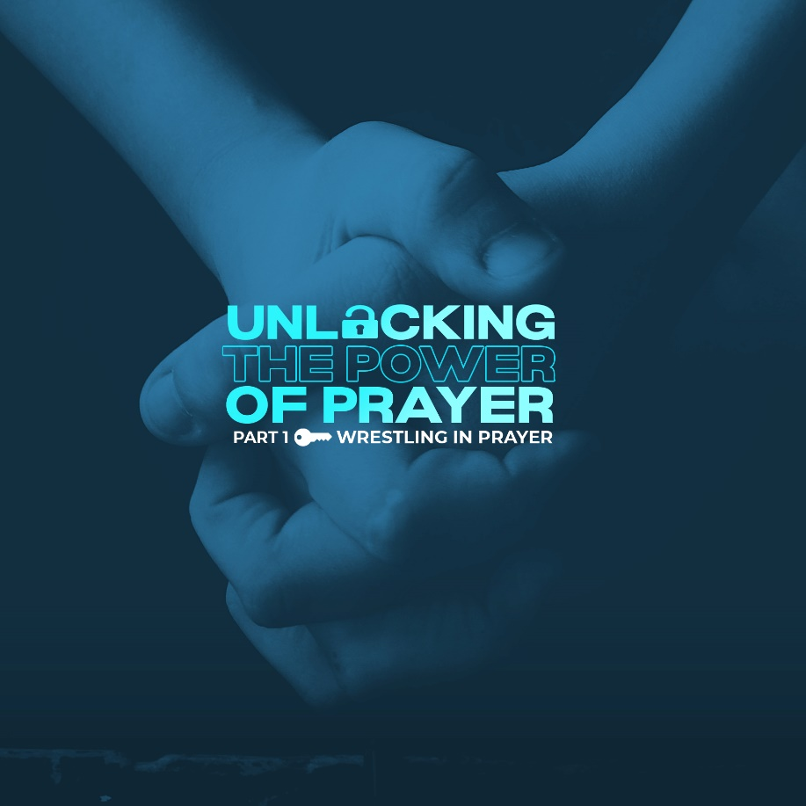

You may have probably wrestled with God for a time or two. Anytime we struggle to understand God and His ways, we wrestle with His will. The idea of wrestling with God makes many of us uncomfortable. It might even make us think something is wrong with us or with our relationship with God.

Just like in a wrestling match, we are like that with God. We grapple, pin down, and struggle to win in prayer. There is a character in the Bible who wrestled with God. His name is Jacob.

Genesis 32:22-32 - “22 That night Jacob got up and took his two wives, his two female servants and his eleven sons and crossed the ford of the Jabbok. 23 After he had sent them across the stream, he sent over all his possessions. 24 So Jacob was left alone, and a man wrestled with him till daybreak. 25 When the man saw that he could not overpower him, he touched the socket of Jacob’s hip so that his hip was wrenched as he wrestled with the man. 26 Then the man said, “Let me go, for it is daybreak.” But Jacob replied, “I will not let you go unless you bless me.” 27 The man asked him, “What is your name?” “Jacob,” he answered. 28 Then the man said, “Your name will no longer be Jacob, but Israel, because you have struggled with God and with humans and have overcome.” 29 Jacob said, “Please tell me your name.” But he replied, “Why do you ask my name?” Then he blessed him there. 30 So Jacob called the place Peniel saying, “It is because I saw God face to face, and yet my life was spared.”” (NIV)

► THE LIFE OF JACOB

Jacob was no stranger to combat. He was born a wrestler. When his twin brother, Esau, was delivered before him, Jacob grabbed his heel. This tussle was so obvious that his mother named him after this incident. His name, Jacob, means “heel grabber”.

Jacob kept striving to find his place in the world. But he never engaged in a fair fight. The Bible describes him as a deceiver, two-faced, dishonest person. When his brother was hungry, he bribed him into giving up his birthright. And when Esau was out hunting, Jacob stole his blessing from their father, Isaac.
When finally, Jacob ran out of tricks, his brother Esau, planned on getting his revenge by killing him. So, Jacob fled to his uncle’s house. Here, Jacob learned that you can’t outrun your sin. It will finally catch up with you. He knew God was calling him to turn around and go home.

Alone with no family with him, God met him in the form of a human being. And Jacob did what he always does; he wrestled. All through the night, he wrestled with God. God tested Jacob by telling him to let go, to give up for it was daybreak. Yet, Jacob responded in Genesis 32:26 - “I will not let you go unless you bless me.” (NIV)

► WRESTLING WITH GOD vs. FIGHTING AGAINST GOD

Wrestling with God is not the same as fighting against Him. Most of the time, this is what we do with God. We want our way. Sometimes, when we demand our way, we're saying to God "I have a vision for my life. I like it this way and not that way." Trouble comes when we want our way more than we want God’s way. Demanding things be done our way reveals that something deeper is at stake in our lives. Something is unsettled, and, for some reason, we believe getting it done our way is going to address this deep concern.

But, trials in life have a way of balancing things out. That’s when we begin to sit up and wrestle with our questions and doubts. A crisis can often strip away our pretenses and bring us face to face with something we would rather not confront. When we’re willing to step into the ring with God and wrestle Him with our doubts, our questions, our hurts, and disappointments, that’s when things begin to change for us. That’s when our hearts are set free and our relationship with God deepens.

Trials have a strange way of bringing people closer together, and the same is true with God. When we’re willing to wrestle with God through hard seasons and things that hurt and are hard to understand, that’s when we grow.

God ordains wrestling prayer so that when He does bless us, we recognize He’s the author of that blessing. If we just got what we wanted, whenever we wanted it, we would not see clearly that God is the giver of the blessing. But when we struggle and strive, we’re better able to remember “God did this. I had no other way of seeing through this sorrow, except that God was with me.”

► HOW DO WE WRESTLE IN PRAYER?

First, we must wrestle in prayer with DISCIPLINE.

This is the most obvious ingredient. We won’t pray much if we don’t set aside time to pray much. We need to guard our time for prayer. Sometimes we think prayer is so spiritual it ought to just happen. Well, it doesn’t just happen. You need to set aside time. For most of us, that’s early in the morning before the rest of the day starts attacking you. For others, at the end of the day. You can start with a prayer list, a verse, or a song. Your prayer life must have structure and discipline.

Second, we must wrestle in prayer with LOVE.

Have you ever considered prayer as an expression, not just of discipline, but of love? If you never pray for someone, how much do you love them? On the other hand, if you love someone deeply, you pray for them often. When you care about people’s hurts and their struggles and their griefs and their souls, you pray. And don’t forget that love moves in a vertical direction, too. We pray because we love to talk to God. Remember, Reading the Bible is where we hear from God, and prayer is where we talk to God.

Lastly, we must wrestle in prayer with FAITH.

When God calls you to wrestle with Him in prayer, it is an invitation for you to exercise your faith. Stay with Him and don’t give up. Do not let Him go until He blesses you! He loves to bless that kind of strong faith so that you will come out refreshed and transformed.

Like Jacob, God opens His hands wide and invites us to wrestle with Him. Allow yourself to receive the invitation. Step into the ring and grab hold of Him and don’t let go. Ask Him for blessing. Ask Him to show up and reveal Himself to you.

LIFE GROUP DISCUSSION:
1) How did the message challenge or encourage you today?

2) Jacob’s story provides an opportunity for self-reflection. What’s one thing you have chased after in life (approval, love, etc.)? How did you chase it, and what did that pursuit cost you and others?

3) What labels (old names) have you been called in the course of your life? Where might God have been in the struggle or process for gaining that new name (Christian)?

